CREATE TABLE employees (

employee_id NUMBER PRIMARY KEY,

hire_date DATE,

job_id VARCHAR2(10)

);

-- Insert sample data

INSERT INTO employees (employee_id, hire_date, job_id) VALUES (1, TO_DATE('2022-01-15', 'YYYY-MM-DD'), 'IT_PROG');

INSERT INTO employees (employee_id, hire_date, job_id) VALUES (2, TO_DATE('2023-03-22', 'YYYY-MM-DD'), 'HR_REP');

INSERT INTO employees (employee_id, hire_date, job_id) VALUES (3, TO_DATE('2024-07-01', 'YYYY-MM-DD'), 'FIN_MGR');

CREATE TABLE job_history (

employee_id NUMBER PRIMARY KEY,

job_id VARCHAR2(10)

);

-- Insert sample data

INSERT INTO job_history (employee_id, job_id) VALUES (1, 'IT_PROG');

INSERT INTO job_history (employee_id, job_id) VALUES (4, 'SA_REP');

INSERT INTO job_history (employee_id, job_id) VALUES (5, 'AD_VP');

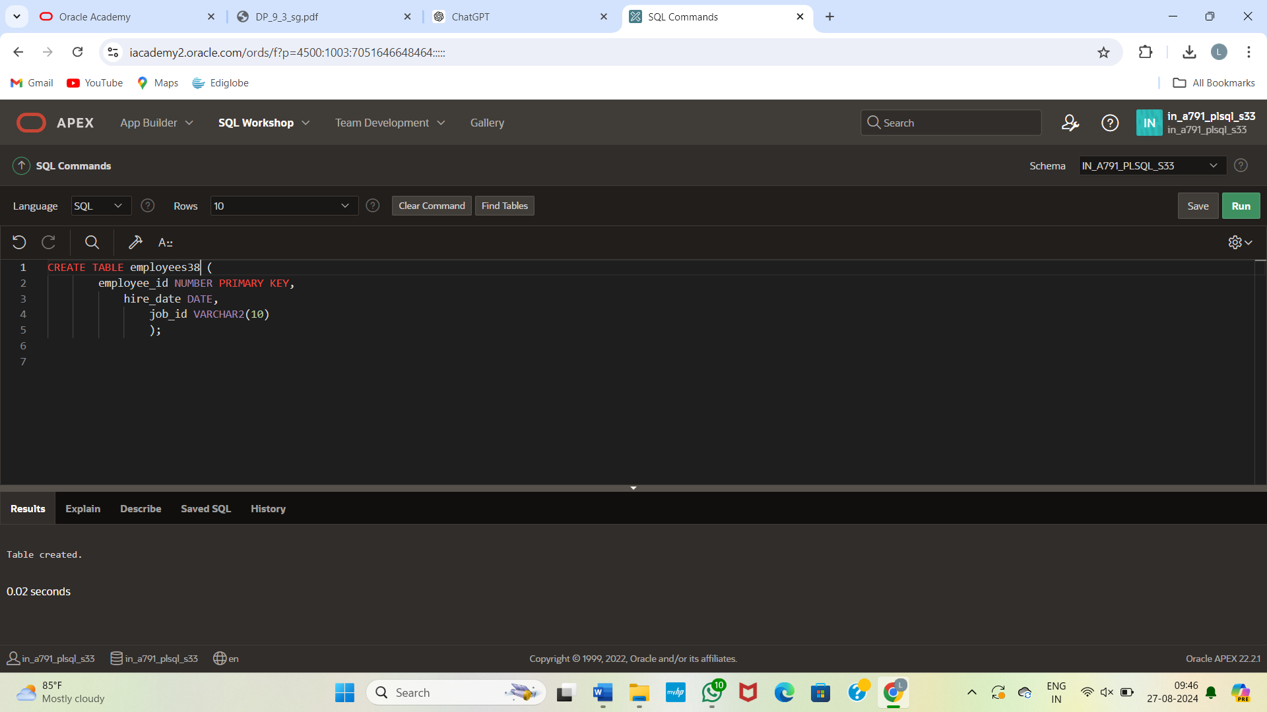

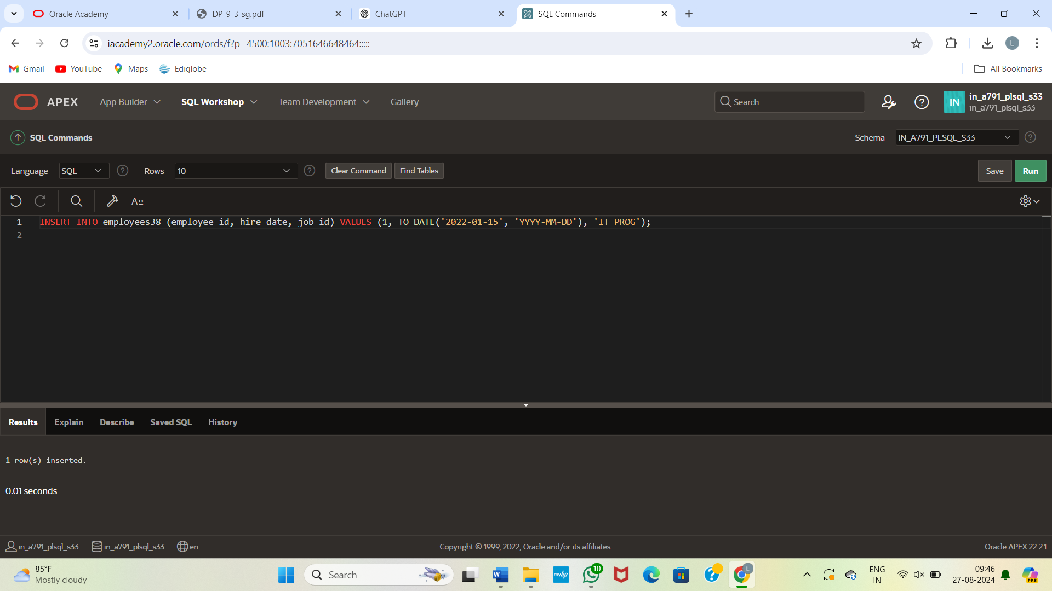

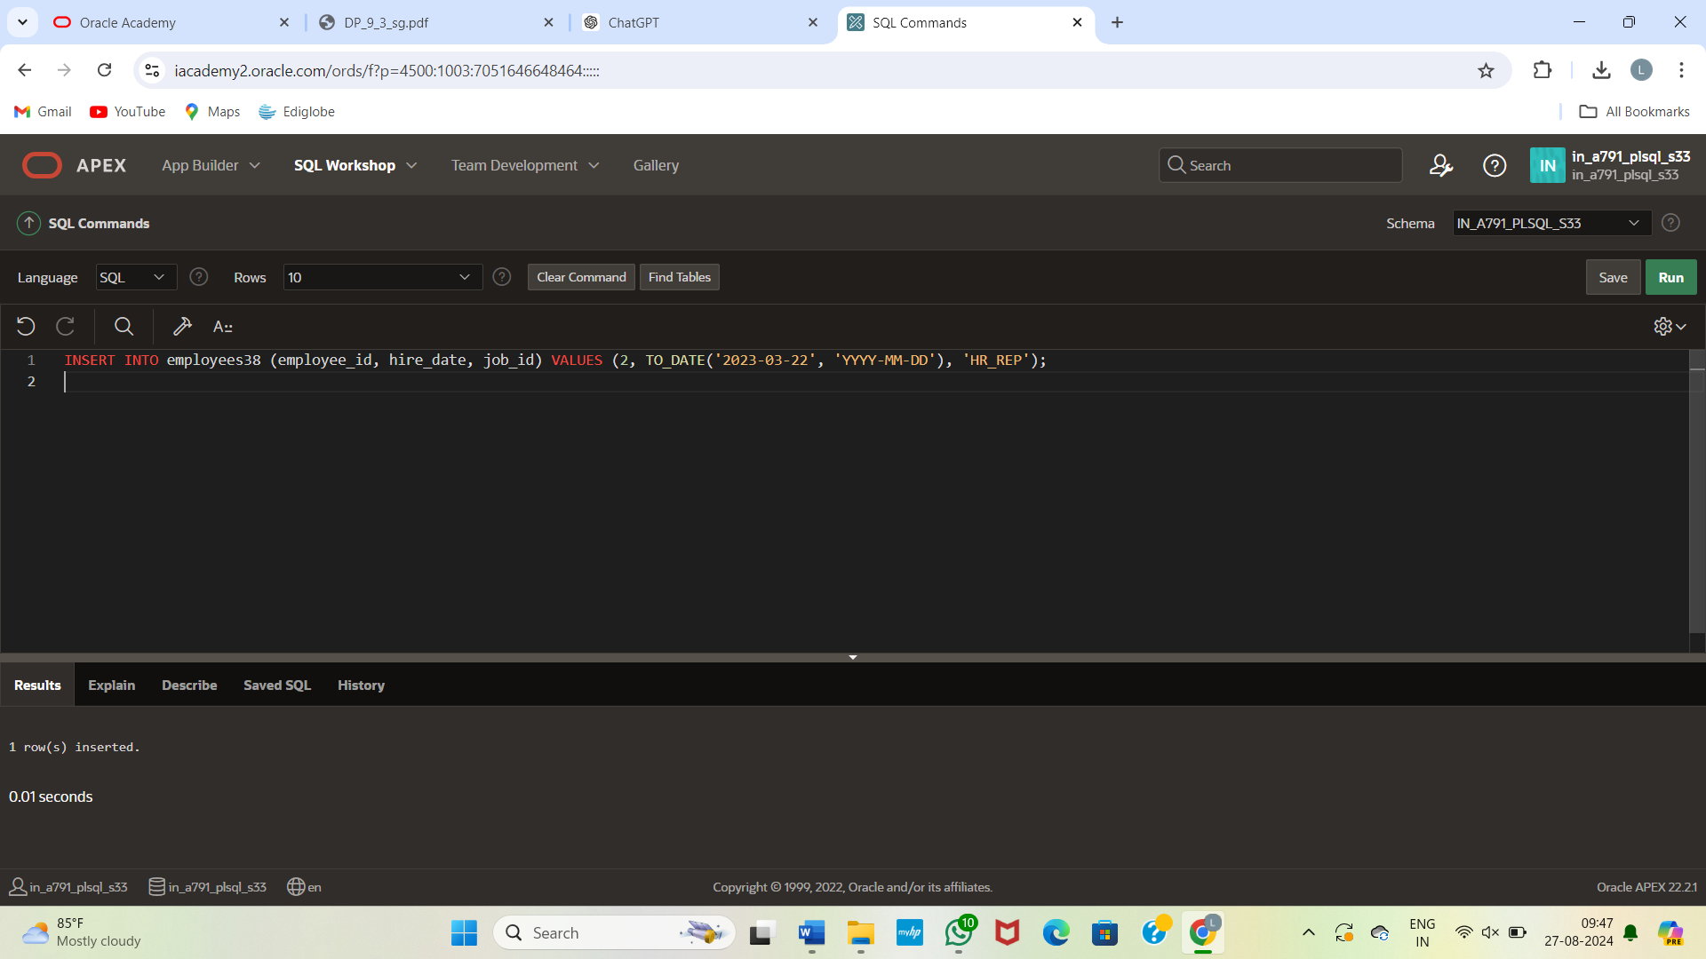

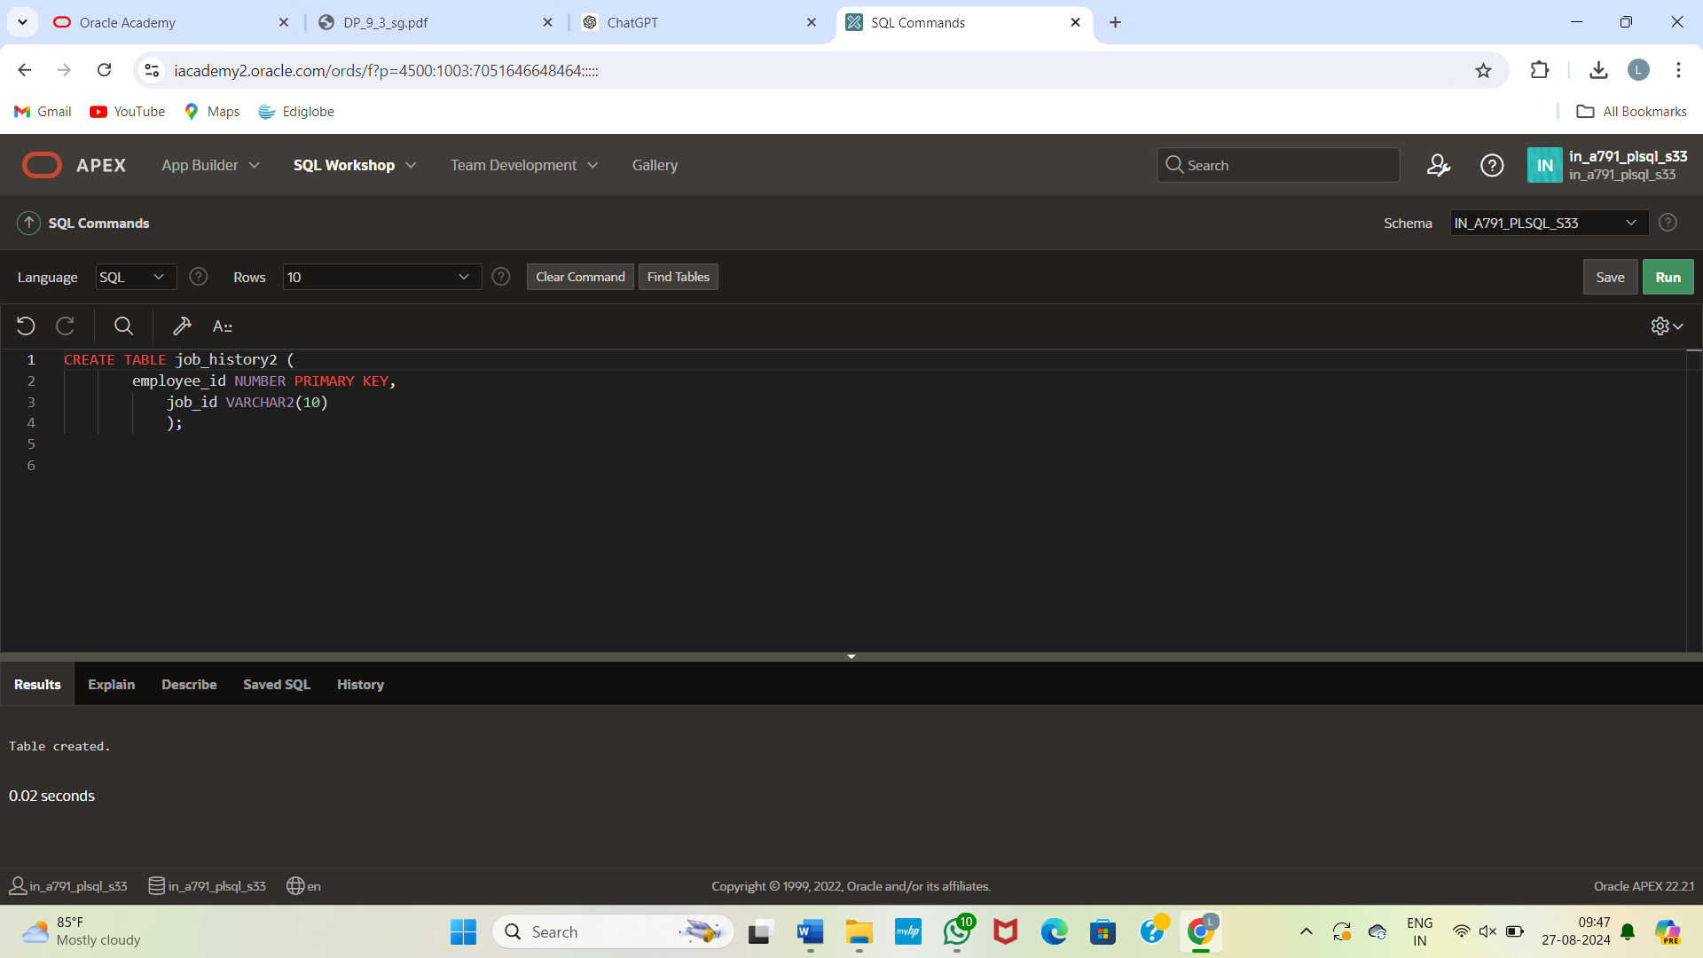

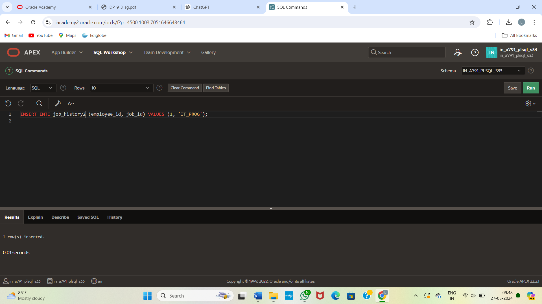

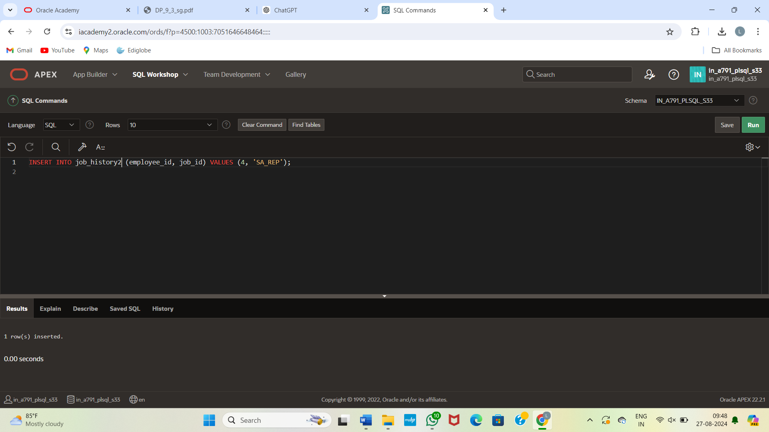

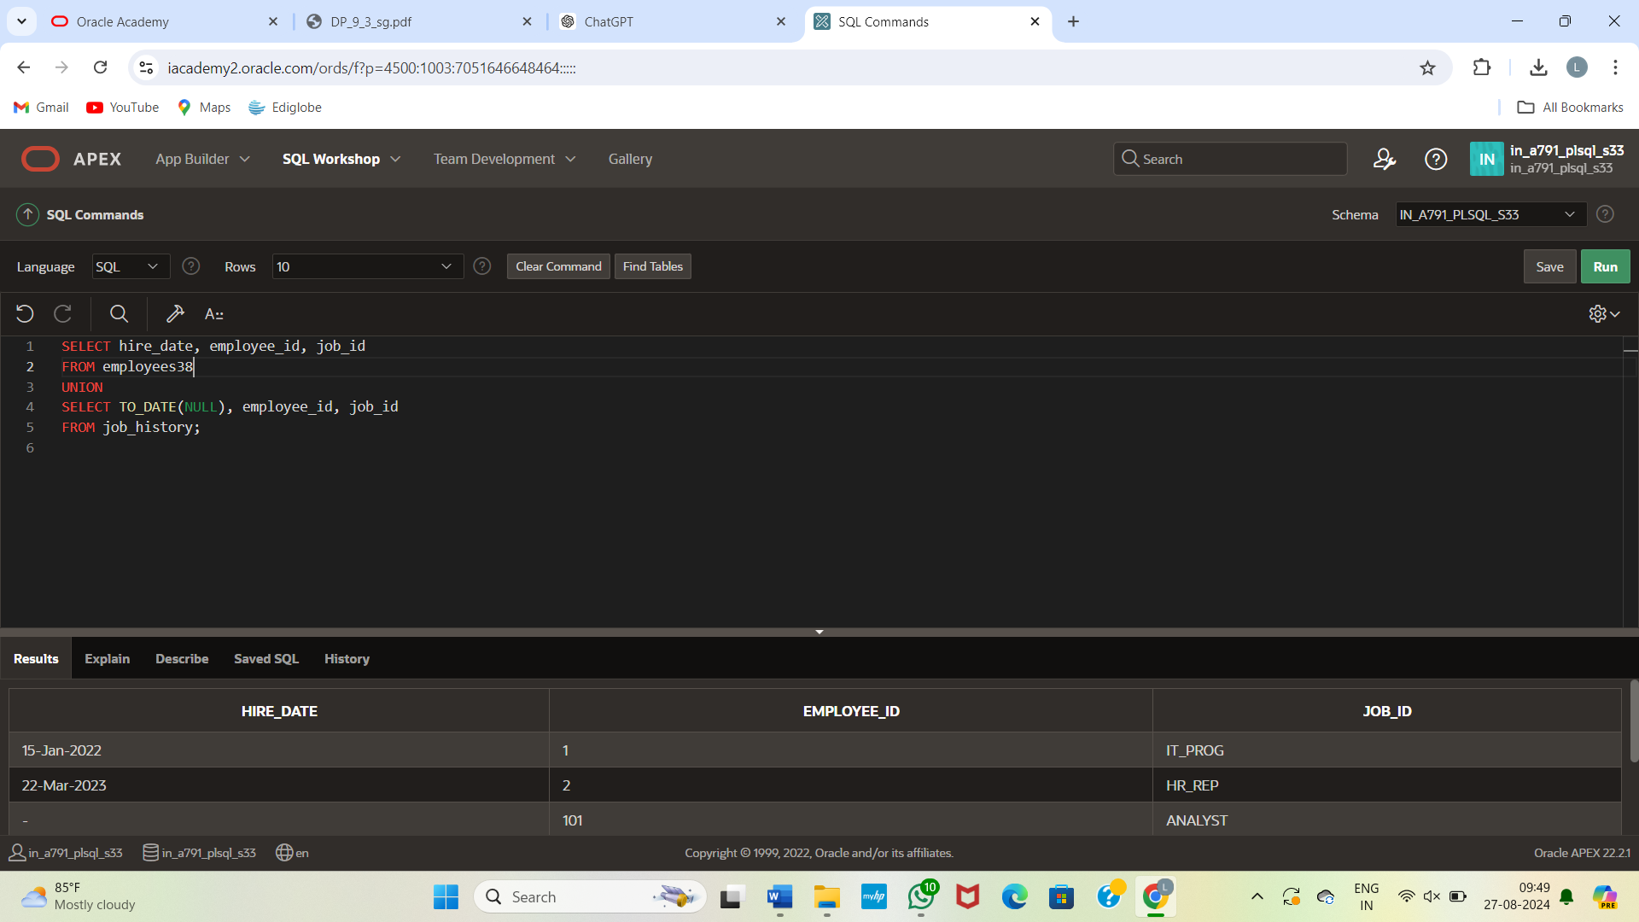

SELECT hire_date, employee_id, job_id

FROM employees

UNION

SELECT TO_DATE(NULL), employee_id, job_id

FROM job_history;